**Trigger 1**

CREATE TRIGGER `MovieCountLessThanOne` BEFORE INSERT ON `Director` FOR EACH ROW

BEGIN

DECLARE msg varchar(255);

IF (NEW.tot_mov_drctd<1)

THEN

SET msg=('Needs to direct atleast one movie');

SIGNAL sqlstate 'CK001' SET message_text=msg;

END IF;

End

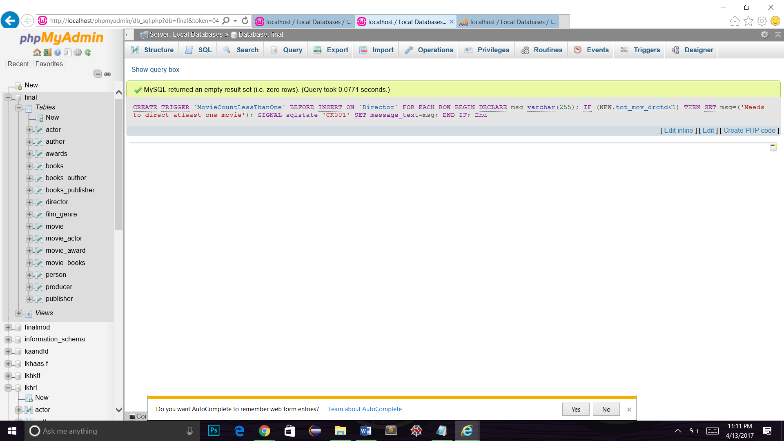

**Checking the working of Trigger 1:**

**Query:**

insert into Director values ( 'D0025', 'Navya', '1984/01/06', '1985/06/15', '1964/11/02', 'Literature', '350000', 0);

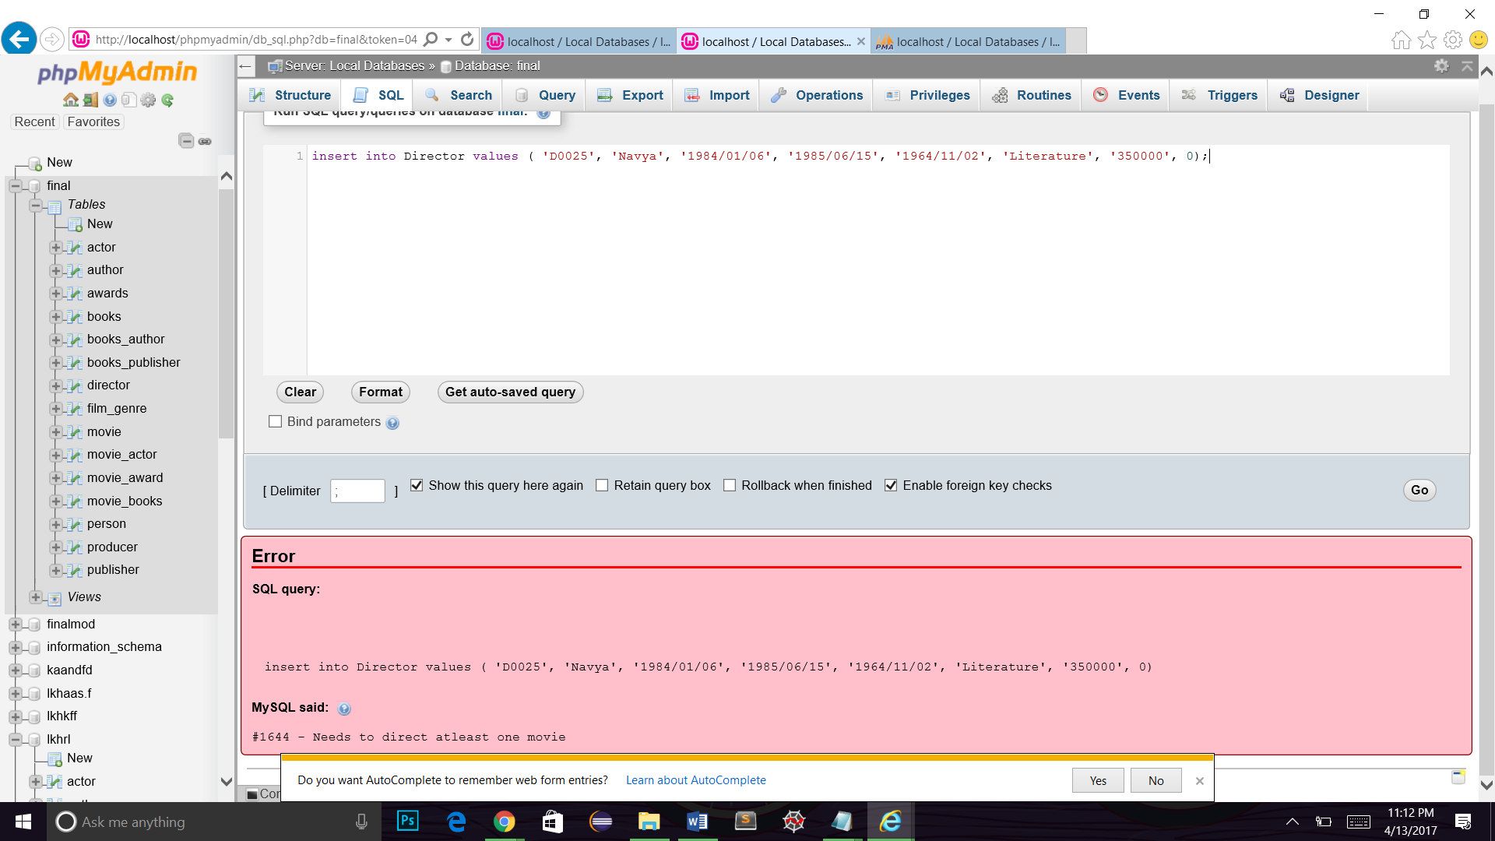

**Trigger 2:**

CREATE TRIGGER `delmovie` BEFORE DELETE on `movie` FOR EACH ROW

BEGIN

DECLARE msg varchar(255);

IF (select count(*) from Movie, Film_Genre where Movie.movie_id = Film_Genre.movie_id > 0 )

THEN

SET msg = 'You cannot delete a Movie Record because its in Film_Genre';

SIGNAL sqlstate 'CK001' SET message_text=msg;

END IF;

END

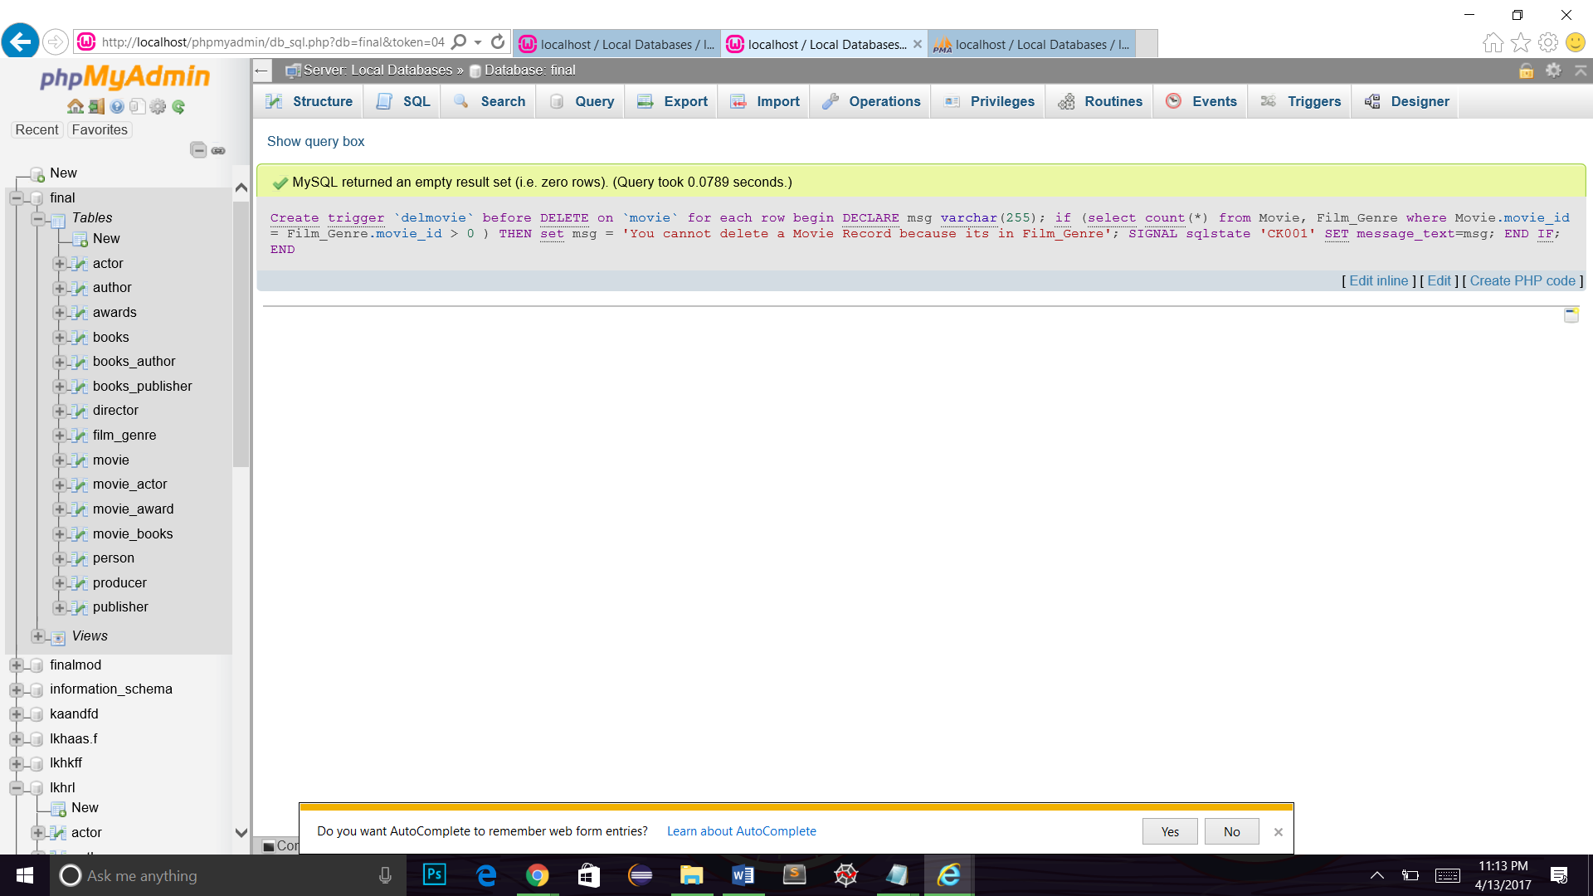

**Checking the working of Trigger 2:**

**Query 2:**

